
UNIVERSITY OF BOLTON
BSc COMPUTING
COURSEWORK SUBMISSION FORM

Student/Centre to complete:

SURNAME/FAMILY NAME: SABIR FORENAMES: NAVEED

BOLTON STUDENT ID: 2224755 EMAIL: ns7crt@bolton.ac.uk

DATE OF SUBMISSION: 17 NOVEMBER 2023 @ 16:00

MODULE NO./TITLE: SWE5202 Data Structures and Algorithms

TUTOR’S NAME: Abdul Razak

COURSEWORK TITLE: Portfolio item 2: Queues, Priority Queues and Linked lists.

Please state if this is your FIRST submission OR REFERRED/DEFERRED submission OR a REPEAT submission?
FIRST

…………………..…………………………………………………………………………………………
Declaration
I hereby declare that this work is my own work. I understand that if I am suspected of plagiarism or another form of cheating, my work be referred to Academic Registrar and/or the Board of Examiners, which may result in me being expelled from the programme. I understand once I submit this work, it will automatically belong to the University of Bolton.

Creative Technologies

Course / Programme: BEng (Hons) in Software Engineering

Module name and code: Data Structures and Algorithms
SWE5202

Tutor: Abdul Razak

Assessment Number: 2

Assessment Title: Queues, Priority Queues and Linked Lists

Weighting 25%

Issue Date: W/C 30 October 2023

Submission Deadline: 17 November 2023 @ 16.00

Figure 1 10
Figure 2 11

Table of Contents
Queues, Priority Queues and Linked Lists 3
Q1. What would be the advantages and disadvantages if Flight Queue were to implement the Queue interface? 4
Q2. Which method(s) should be abstract in AbstractFlightQueue and which should remain concrete? Explain your choice. 5
Q3. Explain the algorithm that you implemented for PriorityFlightQueue2, in particular evaluate the performance and the order of the algorithm using Big O notation. 6
Q4. Does the flight queue appear sorted when you print it? If not why not, see the JavaDocs for a hint? Is it evident that queue was sorted when the flights are landed? 8
UML 10
Part 1 10
Part 2 11
References 12

Queues, Priority Queues and Linked Lists

Queues, priority queues, and linked lists are all important data structures in computer science with unique properties and uses. A queue is a collection of elements that adhere to the First-In-First-Out (FIFO) (R. Perez-Andrade et al., 2008) principle, which is frequently implemented in Java using the Queue interface (Queue Implementations, where parts are added at the back and withdrawn at the front. Priority queues enhance the queue notion by giving priorities to components, guaranteeing that the ones with the greatest priority are dequeued first. Priority queues are often implemented in Java using the PriorityQueue class. (S. Hasan et al., 2016) Linked lists, on the other hand, are linear data structures that store elements in nodes, each of which has a reference to the next node. In Java, the LinkedList class provides a flexible implementation that allows for efficient insertions and removals. Linked lists can be used in a variety of scenarios, including as the foundation for queues and priority queues. (D. Zhang and D. Dechev, 2016).

Q1. What would be the advantages and disadvantages if Flight Queue were to implement the Queue interface?

Implementing the Queue interface in the FlightQueue class would have both advantages and disadvantages.
Advantages:
- Standardization: By implementing the Queue interface, the FlightQueue class becomes more standardized and can be used interchangeably with other classes that implement the Queue interface. This is especially useful if you want to provide a consistent interface across different classes.
- Compatibility: Implementing the Queue interface makes the FlightQueue class compatible with methods or components that expect a Queue. This can be beneficial when integrating with existing code or libraries that work with the Queue interface.
- Polymorphism: Clients of the FlightQueue class can treat it as a Queue, allowing for greater polymorphism. This means that you can write code that works with any class implementing the Queue interface, providing flexibility and ease of maintenance (N. Milojkovic et al., 2015).
Disadvantages:
- Interface Overhead: Implementing an interface comes with the requirement to implement all the methods defined by that interface. If the Queue interface contains methods that are not relevant to the specific behaviour of FlightQueue, it might introduce unnecessary overhead.
- Limited Customization: The Queue interface defines a specific set of methods, and if the requirements of your application demand additional or different methods, you might find the interface limiting. This could lead to workarounds or the need for additional interfaces.
- Implementation Specifics: The Queue interface might not perfectly capture the semantics of your FlightQueue implementation. For example, if your queue has specific behaviours or constraints that are not covered by the Queue interface, you might need to provide additional documentation to clarify the intended usage (A. Proskochylo, M. Zriakhov and A. Akulynichev, 2018).

To summarise, implementing the Queue interface gives standardisation and compatibility advantages at the cost of conforming to the interface's contract, which may or may not fully coincide with the unique requirements of the FlightQueue class. The decision to implement the interface should be based on your application's individual needs and goals (Queue Interface In Java.2016).

Q2. Which method(s) should be abstract in AbstractFlightQueue and which should remain concrete? Explain your choice.

In the AbstractFlightQueue class, the decision of making a method abstract or concrete depends on whether there's a common behaviour that can be shared among all subclasses or if the behaviour is specific to each subclass. Here's a breakdown (H. Ozaki et al., 2003):
- Abstract Methods:
  - joinQueue(Flight f): This method should be abstract because the implementation of adding a flight to the queue might differ among subclasses. For example, the logic for adding a flight to a priority queue versus a normal queue would be different.
  - landFlight(): Similar to joinQueue, this method should be abstract. The logic for landing a flight would vary between the priority queue and the normal queue.
  - size(): This method could be abstract or concrete, depending on whether there's a common way to calculate the size for all subclasses. If the size calculation is the same across all subclasses, it can be concrete. Otherwise, it should be abstract.
  - clear(): Like size(), this method could be abstract, or concrete based on whether there's a common way to clear the queue for all subclasses.
  - display(): This method should be abstract because displaying the flights in the queue might differ between subclasses. For example, displaying a priority queue might involve considering the priority of flights.
- Concrete Methods:
  - If there's common behaviour among all subclasses, those methods can be implemented concretely in the AbstractFlightQueue class. For example, if there's a common way to initialize a queue or common behaviour for some utility methods.
In summary, abstract methods should be used for behaviours that are specific to each subclass, while concrete methods can be used for behaviours that are common among all subclasses. The goal is to provide a consistent interface across all subclasses while allowing for flexibility in their specific implementations (O. Karnalim, 2017).

Q3. Explain the algorithm that you implemented for PriorityFlightQueue2, in particular evaluate the performance and the order of the algorithm using Big O notation.

The algorithm implemented for PriorityFlightQueue2 is based on iterating through the sorted loop of the linked list to find the correct point at which to insert a new flight based on its priority. The algorithm performs a linear search through the linked list, comparing priorities until it finds the correct position to insert the new flight.
Analysis of the performance of this algorithm in terms of Big O notation:
- Time Complexity (Big O): O(n)
The algorithm has a linear time complexity because the time required for the operation is proportional to the number of flights in the linked list. In the worst case, it may need to traverse the entire list to find the correct insertion point. The linear search through the sorted loop results in a time complexity of O(n) (R. Vaz et al., 2017).
- Space Complexity: O(1)
The space complexity is constant because the algorithm does not use additional space that scales with the input size. It only manipulates pointers and variables with fixed memory requirements (S. Phalke, Y. Vaidya and S. Metkar, 2022).
- Performance Evaluation:
  - Advantages:
    - Simplicity: The algorithm is relatively simple and easy to understand.
    - Effective for Small Queues: In scenarios where the number of flights is relatively small, the linear search might not significantly impact performance.
  - Disadvantages:
    - Inefficient for Large Queues: As the number of flights increases, the linear search can become inefficient, especially when compared to more sophisticated data structures like priority queues implemented with heaps.
    - Linear Time Complexity: The algorithm's time complexity grows linearly with the size of the queue, which might be a bottleneck for large datasets.
- Conclusion:
The algorithm is suitable for scenarios where the number of flights is expected to be small or moderate. However, for large datasets, especially in scenarios where frequent insertions and searches are performed, a more efficient data structure like a priority queue implemented with a binary heap or a Tree Map might be preferable (S. Gayathri Devi, K. Selvam and S. P. Rajagopalan, 2011).
In summary, the PriorityFlightQueue2 algorithm provides a simple solution for managing flights with a linear time complexity. Its efficiency depends on the specific use case and the expected size of the queue. For scenarios with larger datasets and frequent operations, alternative data structures with better time complexity may be considered.

Q4. Does the flight queue appear sorted when you print it? If not why not, see the JavaDocs for a hint? Is it evident that queue was sorted when the flights are landed?

In the JavaPriorityFlightQueue class, when flights using the display method are printed, it may not appear sorted. The reason is that the PriorityQueue class does not guarantee a sorted order when using the toString method or iterating over the elements. The iteration order is not guaranteed to be in the natural ordering or in any specific order, as stated in the PriorityQueue documentation.
This means that while the PriorityQueue itself maintains the order based on priority, when iterating over the elements or use toString, the order may not be immediately evident.
However, the priority is maintained when a flight lands. The poll() method of PriorityQueue removes and returns the element with the highest priority. So, when flights land using the landFlight method, it effectively removes the flight with the highest priority, ensuring that the landing operation is done in priority order.
Here's an example modification to the JavaPriorityFlightQueue class to achieve a sorted display:
@Override
void displayInOrder() {
System.out.println("Flights in JavaPriorityFlightQueue (sorted by priority):");
// Create a copy of the priority queue for display
PriorityQueue<Flight> copyQueue = new PriorityQueue<>(priorityQueue);
// Display flights from the copy queue without altering the original queue
while (!copyQueue.isEmpty()) {
Flight nextFlight = copyQueue.poll();
System.out.println(nextFlight.toString());
}
}
- @Override: This annotation indicates that the following method is intended to override a method declared in the superclass or an interface. In this case, it's overriding the displayInOrder method from the superclass.
- void displayInOrder(): This method is designed to display flights in the JavaPriorityFlightQueue in sorted order by priority.
- System.out.println("Flights in JavaPriorityFlightQueue (sorted by priority):");: This line prints a message indicating that the following lines will display flights in sorted order.
- PriorityQueue<Flight> copyQueue = new PriorityQueue<>(priorityQueue);: This line creates a copy of the original priorityQueue using a new PriorityQueue instance. The copy is created with the same comparator as the original queue, effectively creating a copy sorted by priority.
- while (!copyQueue.isEmpty()) {: This line starts a while loop that continues until the copy queue is empty.
- Flight nextFlight = copyQueue.poll();: Inside the loop, it retrieves and removes the head of the copy queue. Since the copy queue is a priority queue, this operation extracts and returns the highest priority element.
- System.out.println(nextFlight.toString());: This line prints the string representation of the flight using the toString method. In this context, it prints the flights in sorted order because the copy queue is a priority queue.
Overall, this method provides a way to display flights in sorted order without modifying the original JavaPriorityFlightQueue's internal state. The use of a copy queue ensures that the original queue remains unchanged.

UML

Part 1
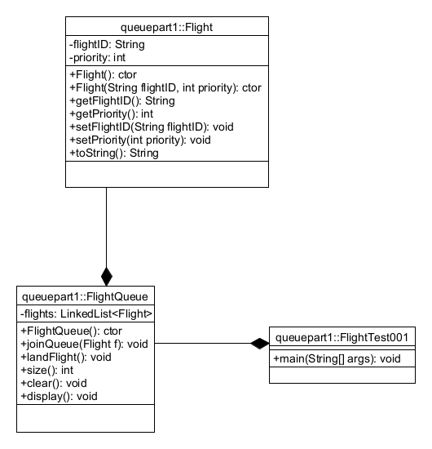
Figure 1

Part 2

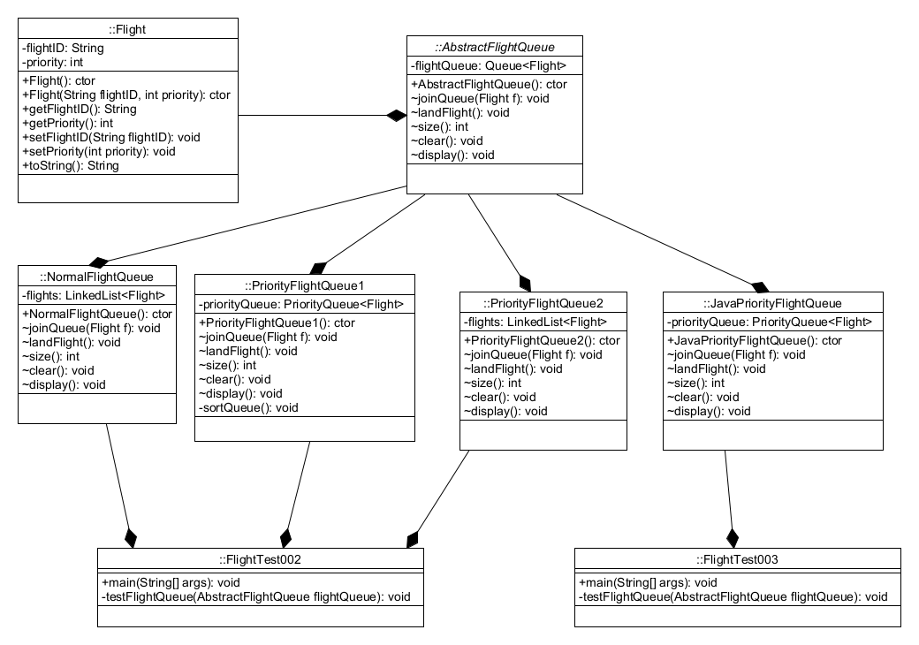
Figure 2

References
D. Zhang and D. Dechev (2016) A Lock-Free Priority Queue Design Based on Multi-Dimensional Linked Lists. IEEE Transactions on Parallel and Distributed Systems, [Online] 27 (3), pp. 613-626 Available from: . [Accessed].
S. Hasan, Z. King, M. Hafiz, M. Sayagh, B. Adams and A. Hindle (2016) Energy Profiles of Java Collections Classes. In:2016 IEEE/ACM 38th International Conference on Software Engineering (ICSE) . , [Online] Available from: . [Accessed].
R. Perez-Andrade, R. Cumplido, F. M. Del Campo and C. Feregrino-Uribe (2008) A Versatile Linear Insertion Sorter Based on a FIFO Scheme. In:2008 IEEE Computer Society Annual Symposium on VLSI . , [Online] Available from: . [Accessed].
Queue Interface In Java. (2016) ed. [Online] : .Available from: https://www.geeksforgeeks.org/queue-interface-java/. [Accessed].
O. Karnalim (2017) An abstract method linearization for detecting source code plagiarism in object-oriented environment. In:2017 8th IEEE International Conference on Software Engineering and Service Science (ICSESS) . , [Online] Available from: . [Accessed].
H. Ozaki, S. Ban, K. Gondow and T. Katayama (2003) An environment for evolutionary prototyping Java programs based on abstract interpretation. In:Tenth Asia-Pacific Software Engineering Conference, 2003. . , [Online] Available from: . [Accessed].
R. Vaz, V. Shah, A. Sawhney and R. Deolekar (2017) Automated Big-O analysis of algorithms. In:2017 International Conference on Nascent Technologies in Engineering (ICNTE) . , [Online] Available from: . [Accessed].
S. Phalke, Y. Vaidya and S. Metkar (2022) Big-O Time Complexity Analysis Of Algorithm. In:2022 International Conference on Signal and Information Processing (IConSIP) . , [Online] Available from: . [Accessed].
S. Gayathri Devi, K. Selvam and S. P. Rajagopalan (2011) An abstract to calculate big o factors of time and space complexity of machine code. In:International Conference on Sustainable Energy and Intelligent Systems (SEISCON 2011) . , [Online] Available from: . [Accessed].
A. Proskochylo, M. Zriakhov and A. Akulynichev (2018) The Effects of Queueing Algorithms on QoS for Real-Time Traffic in Process of Load Balancing. In:2018 International Scientific-Practical Conference Problems of Infocommunications. Science and Technology (PIC S&T) . , [Online] Available from: . [Accessed].
N. Milojkovic, A. Caracciolo, M. F. Lungu, O. Nierstrasz, D. Röthlisberger and R. Robbes (2015) Polymorphism in the Spotlight: Studying Its Prevalence in Java and Smalltalk. In:2015 IEEE 23rd International Conference on Program Comprehension . , [Online] Available from: . [Accessed].
In this assignment I have achieved the following objectives
Tick appropriate box  NA – not attempted : Part – part completed : Full – fully completed | NA | Part | Full
Part 1 |  |  | x
Part 2 |  |  | x
Part 3 |  |  | x

